The Digestion of Chicken Breast

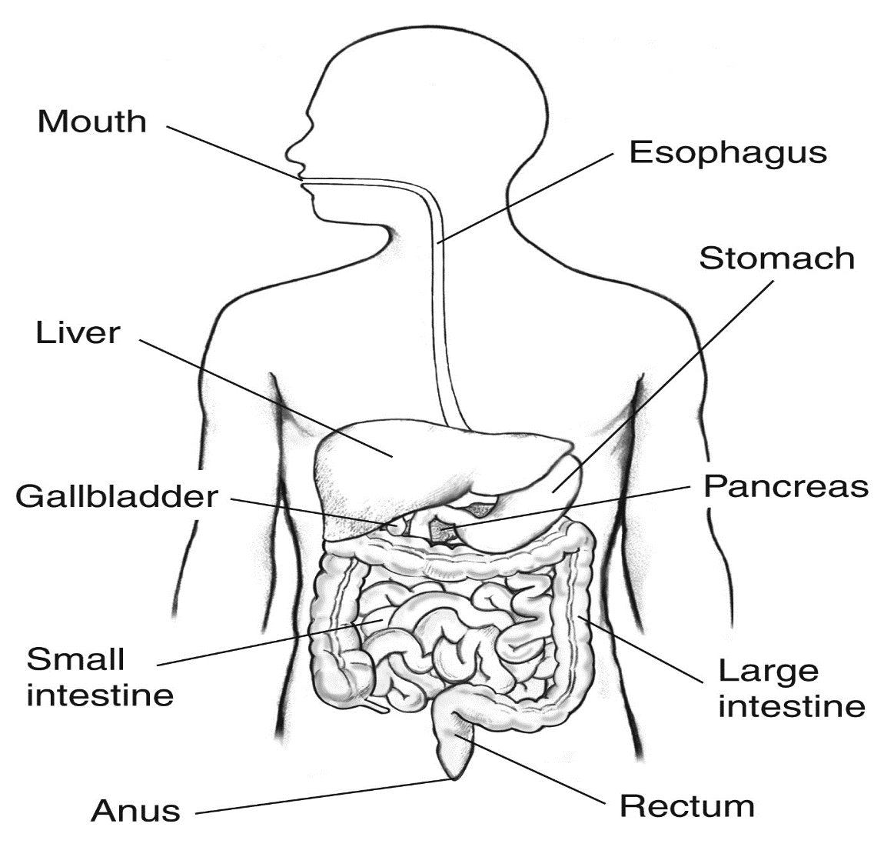

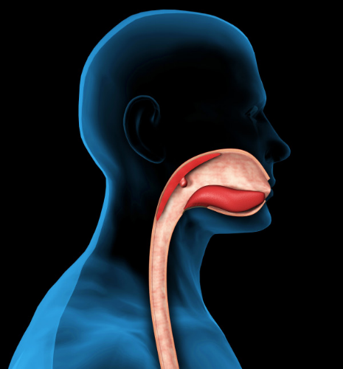Mouth and Oesophagus:

Digestion begins as chicken breast enter the mouth. Ingestion refers to the entry of food into the digestive tract through the mouth. There, food is chewed and mixed with saliva secreted by the salivary glands, which contain enzymes that initiate the breakdown of carbohydrates in the food as well as the digestion of some fats via lingual lipase. The movement of the jaws allows the teeth to grind food into small pieces. This is the first stage of mechanical digestion. Once the chick breast is thoroughly chewed, the tongue.

assists in chewing, mixing saliva and forming food in a round lump called bolus. Then it gets moved to the pharynx. The food bolus passes through the pharynx, the epiglottis closes the trachea and directs the bolus to the esophagus, and the peristaltic wave moves the pellet into the stomach. This process is called peristaltic. The chicken breast will only spend at max 10-30 seconds inside our mouth depending on the quantity and around 3-10 seconds in the esophagus. **(LibGuides: BIO 140 - Human Biology I - Textbook: Chapter 16 - Digestive System Processes and Regulation, 2013)**

Image of mouth and oesophagus

(2018)

Stomach:

The gateway to your stomach is called the lower esophageal sphincter. This sphincter opens and closes the passage between your esophagus and stomach as needed. The stomach uses both mechanical and chemical digestive processes to further break down the chicken breast for absorption. During digestion, the sphincter relaxes and lets food pass through your stomach. During digestion, the muscles push food from the upper part of the stomach to the lower part. This is where gastric juices **(water, hydrochloric acid, electrolytes (sodium, potassium, calcium, phosphate, sulfate, and bicarbonate), and organic substances (mucus, pepsins, and protein)** and enzymes get mechanically combined with the chicken breast. (Britannica, 2023) The powerful mechanical stomach contractions churn the partially digested protein into a more uniform mixture called chyme. Enzymes such as pepsin, within the stomach break down the proteins in the chicken breast into amino acids, allowing it to be easily absorbed into the body through the bloodstream. Chicken breast stays inside the stomach for around 30-140 minutes, depending on the individual’s metabolism. **(The Stomach and Its Role in Digestion | Laparoscopic.MD, 2023)**

Small Intestine:

Breakdown

The chyme enters the first part of the small intestine, the duodenum. This is where the pancreatic juice, made by the pancreas, and bile which is made from the liver and stored in the gall bladder are sent into the small intestine. It would then be mixed with the chyme. The two major pancreatic proteins that process proteins are chymotrypsin and trypsin. The cells that line the small intestine discharge extra enzymes that at last break apart the smaller protein parts into the individual amino acids. The muscle contractions of the small intestine blend and move the processed proteins to the absorption sites. The objective of the 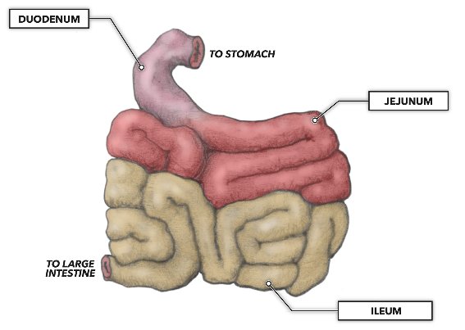digestive process is to break the protein into dipeptides and amino acids for absorption. The small amount of fat present in the chicken breast is broken down into fatty acids by the bile as well. The watery chyme then moves into the jejunum and Ileum where most of the water, amino acid, glucose and nutrients are absorbed. **(Clevelandclinic,2021)**

Small intestine and its different opening labelled.

(2021)

Absorption:

Digestion is competed at this stage. The inward lining of the small intestine, the mucosa, is secured in little finger-like projections called villi that amplify from folded surface of the small intestine, expanding the surface area for absorption. The cells on the villi moreover contain projections, called microvilli. The small intestine absorbs nutrients through its villi and microvilli, utilizing active or passive transport mechanisms depending on the sort of nutrient. Water, fatty acids, and glycerol are ingested passively through simple diffusion, whereas amino acids and glucose require active transport through the cells lining the villi. They will be then distributed in the body through the blood stream. Any substances that aren’t absorbed go into the large intestine. The chyme stays in the small intestine for 2-6 hours.

Nutrient Purpose:

Digestion is important since your body needs supplements from food and drink to work appropriately and remain healthy. Proteins, fats, carbohydrates, vitamins minerals and water are nutrients. Your digestive system breaks nutrients into small parts sufficient for your body to absorb and utilize for vitality, development, and cell repair.

Proteins break into amino acids.

Fats break into greasy acids and glycerol.

Carbohydrates break into simple sugars.

Large Intestine:

When the large intestine gets food from the small intestine, the remaining substances have been liquified by the digestive process and most of the nutrients have been ingested. The colon's work is to dry out what's left of the food and shape it into a solid substance called faeces. Feces or stools are comprised of 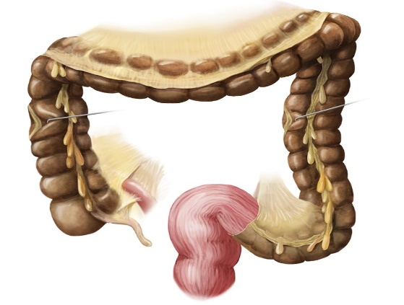indigestible food, bacteria, inorganic salts, unabsorbed substances, and epithelial cells, in addition to sufficient water for it to pass out of the body. It does this by gradually absorbing water and electrolytes as its muscle system moves the waste along **(Clevelandclinic.2021).** Addition, large intestine absorbs minerals including salt, potassium, and chloride, which are needed to maintain body fluids balance. The bacteria that live inside the large intestine then break down the remaining carbohydrates or starches to release vitamin b or k that are then absorbed through the mucosa. It will then go to the bloodstream and be transported. The large intestine is home to many lymphatic tissues, which are important for immunity. They help produce antibodies against commensal bacteria but can be helpful in fighting harmful bacteria, preventing infection. The waste material will spend about 15 – 59 hours, averaging 36 hours for most foods, in the large intestine before being expelled from the body **(and, 2023).**

Large intestine, rectum, and the anus

(2017)

Elimination and Faeces:

The final stage for digestive system is elimination. The large intestine sends the faeces to the rectum. It’s kept there till it is eliminated through the anus and exits the body. The anus is the external opening end of the rectum.

References:

1.Bennett, C. (2022) *What does the large intestine do?*, *News*. Available at: <https://www.news-medical.net/health/What-Does-the-Large-Intestine-Do.aspx> (Accessed: May 7, 2023).

2.Libretexts (2020) *5.4: Protein digestion, absorption and metabolism*, *Medicine LibreTexts*. Libretexts. Available at: <https://med.libretexts.org/Courses/American_Public_University/APUS%3A_An_Introduction_to_Nutrition_(Byerley)/APUS%3A_An_Introduction_to_Nutrition_1st_Edition/05%3A_Proteins/5.04%3A_Protein_Digestion_Absorption_and_Metabolism> (Accessed: May 7, 2023).

*3.Food's journey through the digestive system* (no date) *Science Learning Hub*. Available at: <https://www.sciencelearn.org.nz/resources/1849-food-s-journey-through-the-digestive-system> (Accessed: May 7, 2023).